VOLUME 2
ACTUATORS

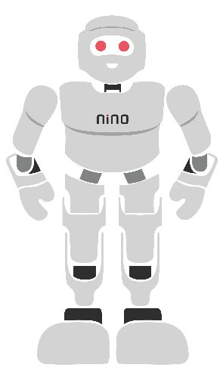

Contents Sheet

S. No. | Heading | Description
1 | Introduction to Actuators | Fundamentals, types, working principles, and applications of actuators.
2 | DC Motor and Servo Motor Control | Motor construction, operation, direction control, and interfacing.
3 | Motor Driver Circuits and H-Bridge | L298N motor driver, pin configuration, and direction control.
4 | DC Motor Control Using Raspberry Pi | Hardware setup, GPIO programming, and forward/reverse motor control.
5 | Speed and Position Control | PWM, duty cycle, motor speed regulation, and servo positioning.
6 | Servo Motor Control Using Raspberry Pi | Servo interfacing, PWM programming, and angular-position control.
7 | Applications in Robotics | Use of actuators and motor control in navigation, robotic arms, and automation.
8 | Feedback Systems (Additional) | Open-loop and closed-loop control, sensors, and feedback mechanisms.
9 | Motor Characterisation (Additional) | Measurement of motor speed, voltage, current, and load performance.
Note: Sections 8 and 9 are recommended additions; they are not covered in detail in the current document.

Introduction to Actuators

Introduction
Robots and embedded systems interact with the surrounding environment through sensors and actuators.
Sensors collect information such as distance, temperature, light, pressure, or touch from the environment. The controller processes this information and sends commands to actuators. Actuators then convert these commands into physical actions such as movement, rotation, or switching.
Without actuators, it cannot perform useful tasks. Together, they form the foundation of every robotic and automation system. This chapter introduces the fundamentals actuators before studying specific devices such as the DC motor, servo motor, and motor drivers in the following chapters.
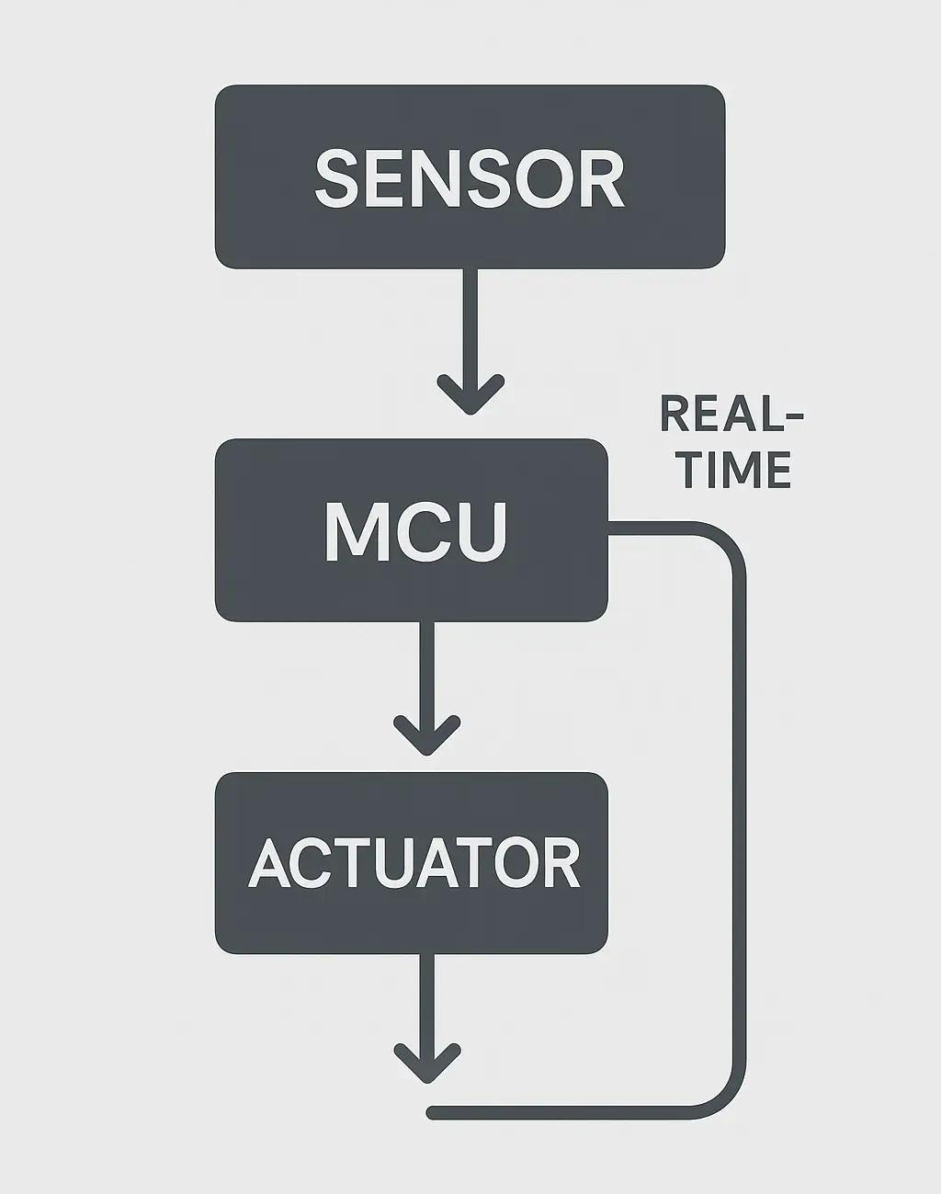
Figure 1.1. Basic Sensor–Controller–Actuator System

Definition
An actuator is a device that converts an electrical control signal into physical movement or action.

What is an Actuator?
An actuator receives control signals from a controller and performs a physical action.
Examples include:
- Rotating a motor
- Opening or closing a valve
- Moving a robotic arm
- Operating a relay
- Turning an LED ON or OFF
Actuators convert electrical energy into mechanical motion or other physical quantity outputs.
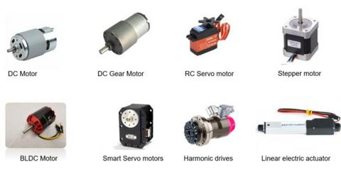
Figure 1.2: Examples of Common Actuators

Types of Actuators
Several actuators are commonly used in embedded systems.
Type of Actuator | Energy Source | Typical Application
Electrical Actuator | Electrical energy | DC motors, servo motors, relays, robotic systems
Pneumatic Actuator | Compressed air | Industrial automation, pneumatic cylinders
Hydraulic Actuator |  | Heavy machinery, excavators, hydraulic presses
  Pressurized fluid
Thermal Actuator | Heat energy | Thermostats, temperature-controlled valves
Note: This module primarily focuses on Electrical Actuators

Types of Electrical Actuators
Actuator | Function | Typical Application
DC Motor | Continuous rotation | Mobile robots
Servo Motor | Controlled angular movement | Robotic arms
Stepper Motor | Precise rotational movement | CNC machines, 3D printers
Relay | Electrical switching | Home automation
Solenoid | Linear motion | Door locks
In this module, you will focus primarily on DC motors and servo motors.

Working Principle of a Robotic System
A robotic system typically follows a sequence of operations:
- Sensors detect environmental conditions.
- The controller receives sensor data.
- The controller processes the information.
- A decision is made based on the program.
- Control signals are sent to actuators.
- Actuators perform the required action.
This continuous sensing and action cycle allows robots to respond intelligently to changing conditions.

Actuators in Robotics
Every robot uses multiple sensors and actuators.
Examples
Robot Function | Sensor | Actuator
Obstacle Detection | Ultrasonic Sensor | DC Motor
Line Following | IR Sensor | DC Motor
Touch-Based Operation | Touch Sensor | Servo Motor
Robotic Arm | Position Sensor | Servo Motor
By combining different sensors and actuators, robots can perform complex tasks accurately and efficiently.

Applications
Actuators are used in many fields.

Robotics
- Obstacle avoidance
- Autonomous navigation
- Robotic arms
- Line-following robots

Home Automation
- Smart lighting
- Automatic doors
- Security alarms

Industrial Automation
- Conveyor systems
- Quality inspection
- Process monitoring

Healthcare
- Patient monitoring
- Medical robots
- Assistive devices

Importance in Embedded Systems
Embedded systems rely on sensors to gather information and actuators to perform actions.
Examples include:
- Reading environmental conditions
- Controlling motors
- Operating alarms
- Monitoring industrial equipment
- Automating household appliances
The interaction between sensing, processing, and actuation enables intelligent and autonomous system behaviour.

DC Motor and Servo Motor Control

Introduction
Motors are among the most important actuators used in robotics and embedded systems. They convert electrical energy into mechanical motion, allowing robots to move, rotate wheels, lift objects, or position robotic arms.
Two commonly used motors in embedded systems are the DC motor and the servo motor.
A DC motor is mainly used for continuous rotational motion, while a servo motor is used for accurate angular positioning. Selecting the appropriate motor depends on the requirements of the application.
In this chapter, students will learn the construction, working principles, interfacing, programming, and applications of DC and servo motors.
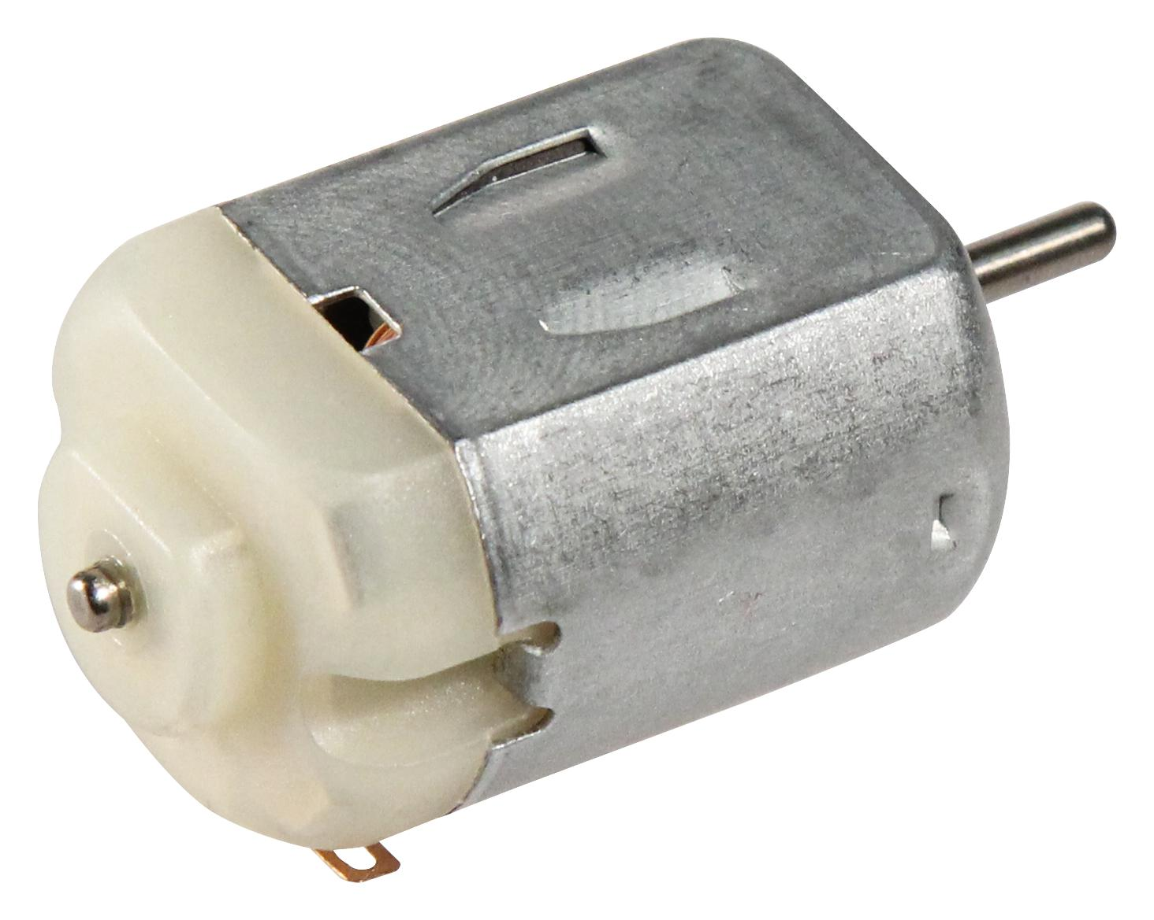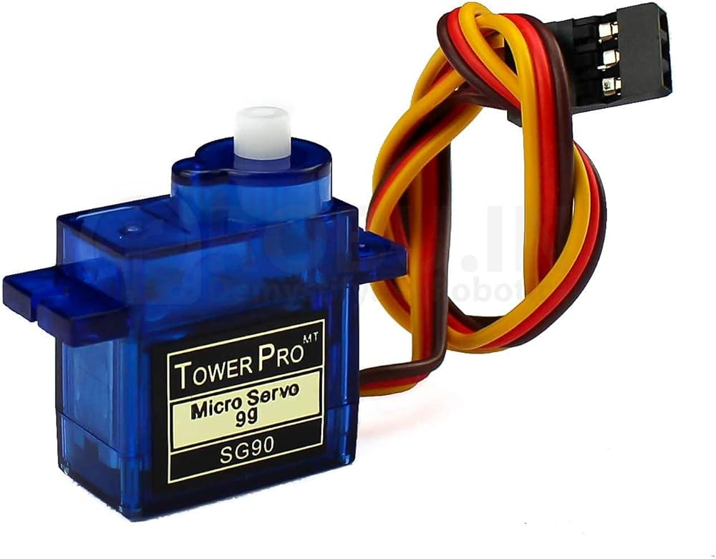
Figure 5.1: DC Motor and Servo Motor

Definition
A DC Motor is an electric motor that converts direct current (DC) electrical energy into continuous rotational motion.
A Servo Motor is an electric motor with a built-in control mechanism that rotates to a specified angular position based on control signals.

DC Motor
A DC motor is one of the simplest and most widely used motors in robotics.
When electrical current flows through the motor, it produces rotational motion. Reversing the current changes the direction of rotation.
DC motors are commonly used where continuous movement is required.
Examples include:
- Robot wheels
- Conveyor belts
- Cooling fans
- Water pumps
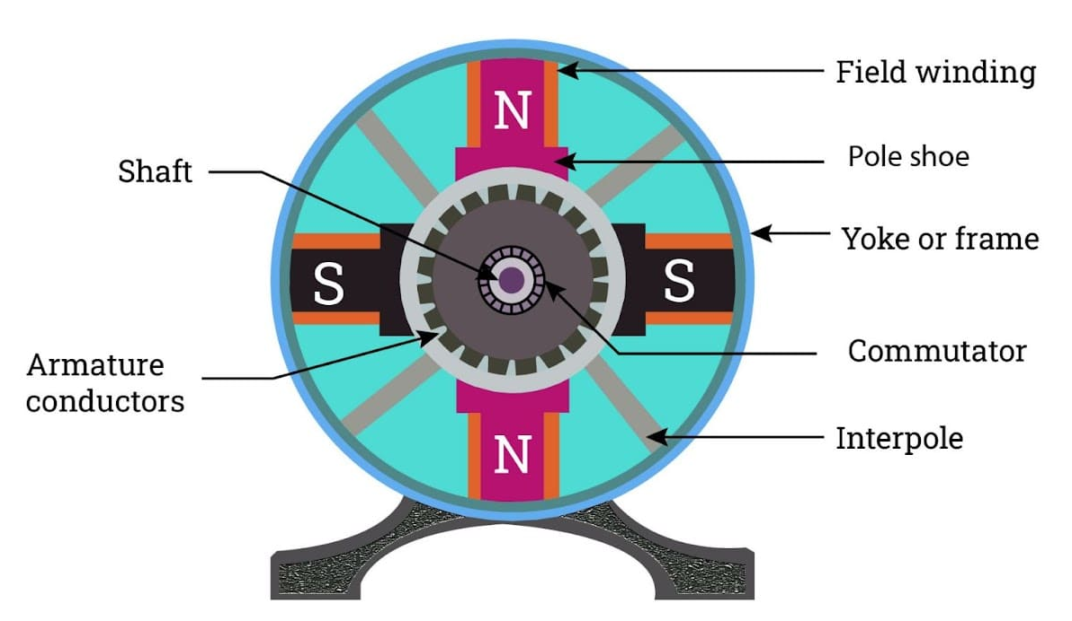
Figure 5.2: Construction of a DC Motor

Working Principle of a DC Motor
A DC motor operates by converting electrical energy into mechanical rotation.
The basic working process is:
- Electrical power is supplied to the motor.
- Current flows through the motor windings.
- A magnetic field is produced.
- The interaction of magnetic fields generates rotational motion.
- The motor shaft rotates continuously until the power supply is removed.
The direction of rotation depends on the direction of current flow.
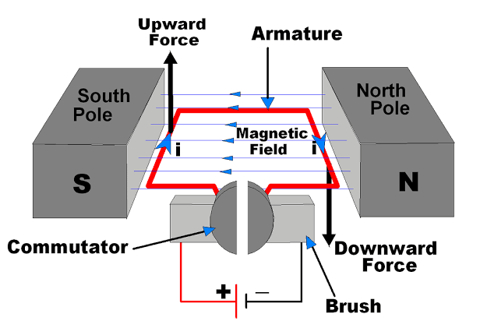
Figure 5.3: Working Principle of a DC Motor

Controlling a DC Motor
The operation of a DC motor can be controlled in several ways.

Direction Control
The motor can rotate:
- Clockwise (CW)
- Counterclockwise (CCW)
The direction is controlled by changing the polarity of the voltage supplied to the motor.

Speed Control
The speed of a DC motor is commonly controlled using Pulse Width Modulation (PWM).
By changing the duty cycle of the PWM signal, the average power supplied to the motor changes, resulting in different motor speeds.
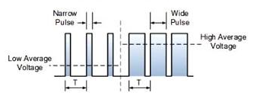
Figure 5.4: PWM-Based Speed Control of a DC Motor

Servo Motor
Unlike a DC motor, a servo motor does not rotate continuously under normal operation.
Instead, it moves to a specific angular position as instructed by the controller.
Typical movement range:
- 0°
- 90°
- 180°
Servo motors are widely used where accurate positioning is required.
Applications include:
- Robotic arms
- Camera pan-tilt systems
- Robot joints
- Automatic doors
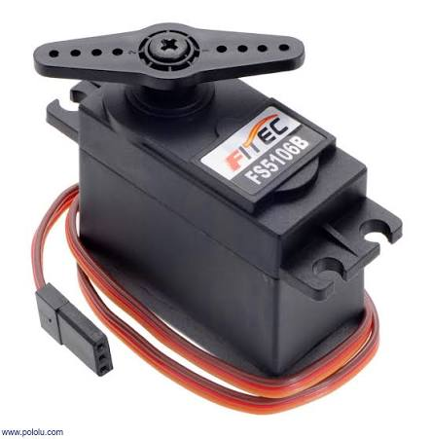
Figure 5.5: Standard Servo Motor

Working Principle of a Servo Motor
A servo motor contains:
- DC motor
- Gear mechanism
- Position sensor
- Control circuit
The controller sends a control signal to the servo motor.
The internal control circuit compares the desired position with the current position and rotates the motor until the required angle is reached.
This closed-loop operation enables accurate positioning.
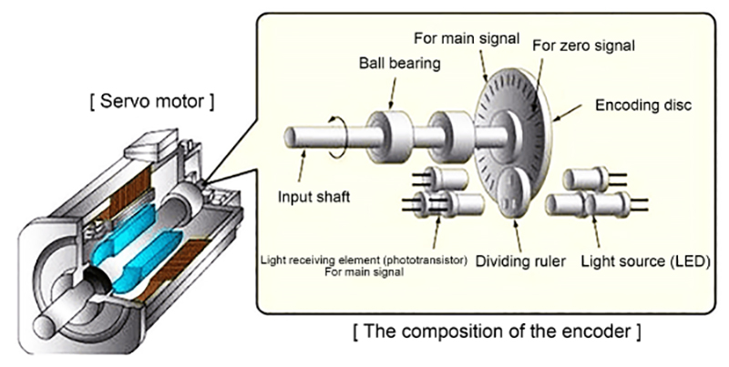
Figure 5.6: Internal Working of a Servo Motor

Interfacing a Servo Motor with Arduino
A typical servo motor has three wires.
Servo Wire | Arduino Connection
VCC | 5V
GND | GND
Signal | Digital PWM Pin (Example: Pin 9)
The Arduino controls the servo using PWM signals.
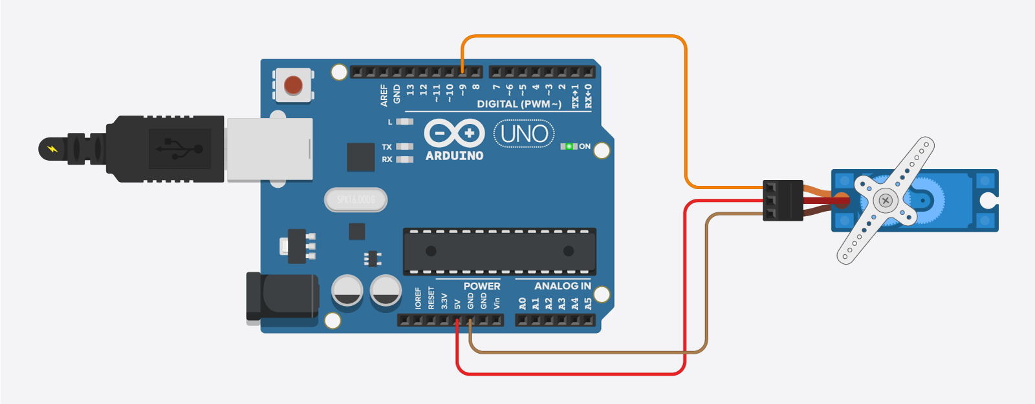
Figure 5.7: Servo Motor Connected to Arduino

Comparison Between DC Motor and Servo Motor
Feature | DC Motor | Servo Motor
Motion | Continuous rotation | Fixed angular position
Control | Speed and direction | Angular position
Feedback | Generally absent | Built-in position feedback
Precision | Moderate | High
Typical Applications | Robot wheels, fans | Robotic arms, joints, steering

Applications

DC Motor Applications
- Mobile robots
- Conveyor systems
- Cooling fans
- Pumps
- Electric vehicles

Servo Motor Applications
- Robotic arms
- Camera positioning
- Pick-and-place robots
- Automatic gates & CNC machines

Importance in Robotics
Motors provide movement to robotic systems.

DC Motors
Used for:
- Robot movement
- Wheel rotation
- Autonomous navigation
- Drive mechanisms

Servo Motors
Used for:
- Joint movement
- Arm positioning
- Gripper control
- Camera orientation
By combining DC motors and servo motors, robots can perform both locomotion and precise manipulation.

Motor Driver Circuits (L298N) and H-Bridge Concepts

Introduction
Microcontrollers such as the Arduino can generate digital control signals, but they cannot directly supply the high current required to operate DC motors. Attempting to connect a motor directly to a microcontroller may damage the controller due to excessive current draw.
To safely control motors, an intermediate circuit called a motor driver is used. A motor driver receives low-power control signals from the microcontroller and supplies the required current and voltage to the motor.
One of the most widely used motor driver modules in educational robotics is the L298N Motor Driver Module. It enables the Arduino to control the direction and speed of DC motors using the H-Bridge principle.
This chapter introduces the L298N motor driver, explains the H-Bridge concept, and demonstrates how DC motors are controlled using Arduino.

Definition
A motor driver is an electronic circuit that acts as an interface between a controller and a motor, allowing the controller to safely regulate the motor's operation.
An H-Bridge is an electronic switching circuit that allows a DC motor to rotate in both clockwise and counterclockwise directions by changing the direction of current flow.

Why is a Motor Driver Required?
A motor requires much more current than an Arduino output pin can safely provide.
A motor driver is used because it:
- Protects the microcontroller.
- Supplies sufficient current to the motor.
- Controls motor direction.
- Controls motor speed using PWM.
- Allows one controller to operate multiple motors.
Without a motor driver, reliable operation of DC motors in robotic systems is not possible.

L298N Motor Driver Module
The L298N is a dual H-Bridge motor driver capable of controlling two DC motors independently.
It accepts low-power logic signals from the Arduino and provides the required power to drive motors.

Main Features
- Controls two DC motors independently
- Supports forward and reverse rotation
- PWM-based speed control
- Simple Arduino interfacing
- Suitable for educational robotic projects
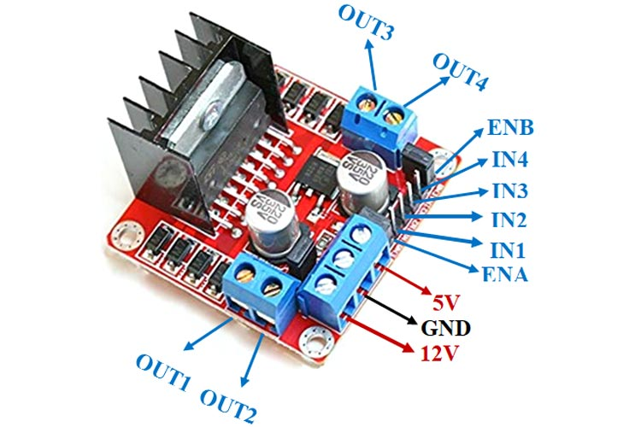
Figure 6.3: L298N Motor Driver Module

Pin Description of L298N
The commonly used pins of the L298N module are shown below.

Pin | Function
ENA | Enable/PWM for Motor A
IN1 | Direction control input 1for Motor A
IN2 | Direction control input 2 for Motor A
IN3 | Direction control input 3 for Motor B
IN4 | Direction control input 4 for Motor B
OUT1 | Output to Motor A
OUT2 | Output to Motor A
OUT3 | Output to Motor B
OUT4 | Output to Motor B
+12V / VIN | Motor power supply
GND | Ground
5V | Logic supply (module dependent)
For controlling a second motor, similar pins (ENB, IN3, IN4, OUT3, OUT4) are provided.

H-Bridge Concept
An H-Bridge is an electronic switching arrangement that controls the direction of current through a DC motor.
By changing the switching pattern, the motor can rotate:
- Clockwise
- Counterclockwise
- Stop
The name H-Bridge comes from the arrangement of switches, which resembles the letter H.
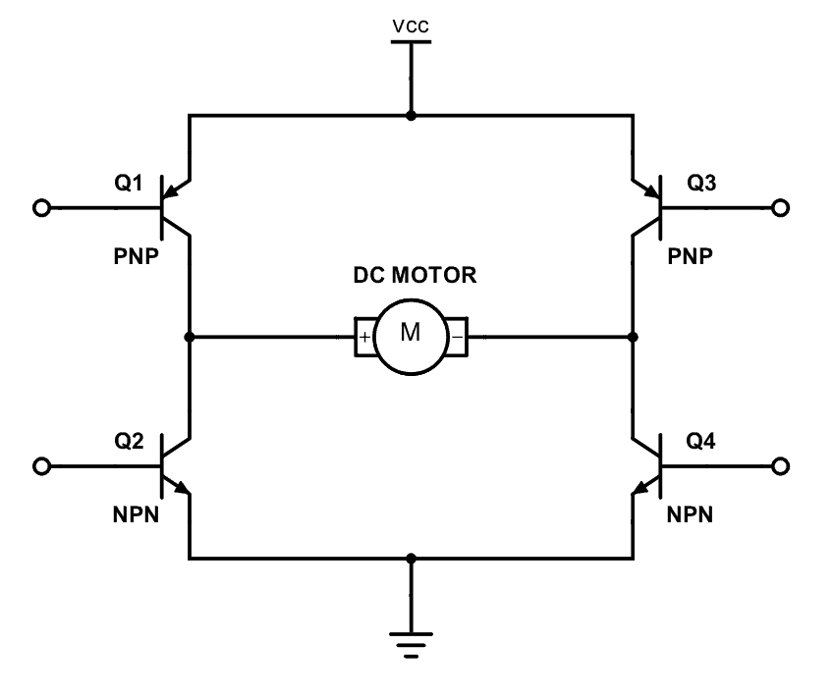
Figure 6.5: Basic H-Bridge Circuit

Motor Direction Control Using an H-Bridge
The direction of rotation depends on the input signals.
IN1 | IN2 | Motor Operation
LOW | LOW | Stop
HIGH | LOW | Clockwise Rotation
LOW | HIGH | Counterclockwise Rotation
HIGH | HIGH | Stop (Brake Mode)
This logic allows the Arduino to change the motor's direction through simple digital outputs.

Interfacing L298N with Arduino
A typical connection between Arduino, the L298N module, and a DC motor is shown below.
L298N Pin | Arduino Pin
ENA | PWM Pin 9
IN1 | Digital Pin 8
IN2 | Digital Pin 7
GND | GND
The DC motor is connected between OUT1 and OUT2, while an external power supply is connected to the motor driver's power input.

Applications
The L298N motor driver is commonly used in:
- Mobile robots
- Line-following robots
- Obstacle-avoidance robots
- Conveyor systems
- Educational robotics projects
- Smart automation systems

Importance in Robotics
Motor drivers are essential because they allow embedded controllers to safely operate motors.
In robotic systems, they are used to:
- Drive robot wheels
- Reverse motor direction
- Control movement
- Interface motors with Arduino
- Build autonomous mobile robots
Understanding motor drivers is a fundamental step toward designing reliable robotic control systems.

Activity: DC Motor Direction Control using Raspberry Pi 5B

Aim
To interface two DC motors with the Raspberry Pi 5B through the L298N motor driver and control their direction of rotation by generating appropriate digital control signals for forward, reverse, and stop operations.

Components Required
Component | Quantity
Raspberry Pi 5 Model B | 1
Breadboard | 1
L298N Motor Driver Module | 1
DC Motor | 2
12 V Battery | 1
Jumper Wires | As required
USB Cable | 1
MicroSD Card with Raspberry Pi OS | 1

Theory
- Pulse Width Modulation (PWM) is a technique used to control the average voltage supplied to a DC motor by varying the duty cycle of the input signal.
- The L298N Motor Driver (Fig. 1(a)) is used to control the speed and direction of two DC motors using PWM and digital control signals.
- The DC Motor (Fig. 1(b)) converts electrical energy into rotational motion, and its speed varies with the applied PWM signal.
- When the two input signals of a motor are given opposite logic levels, the L298N reverses the polarity applied across the motor terminals, thereby changing its direction of rotation.
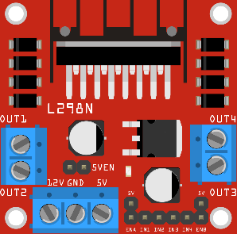 | 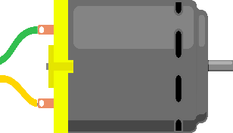
Fig. 1(a). L298N Motor Driver Module | Fig. 1(b). DC Motor

Motor Control Logic

L298N IN1 | L298N IN2 | Motor A Direction
LOW | LOW | Stop (Initial State)
HIGH | LOW | Forward
LOW | HIGH | Reverse
HIGH | HIGH | Stop / Brake condition

Similarly, Motor B is controlled using IN3 and IN4.

In this experiment, both motors are commanded together so that the robot moves forward, stops, reverses, and stops again.

Schematic Diagram
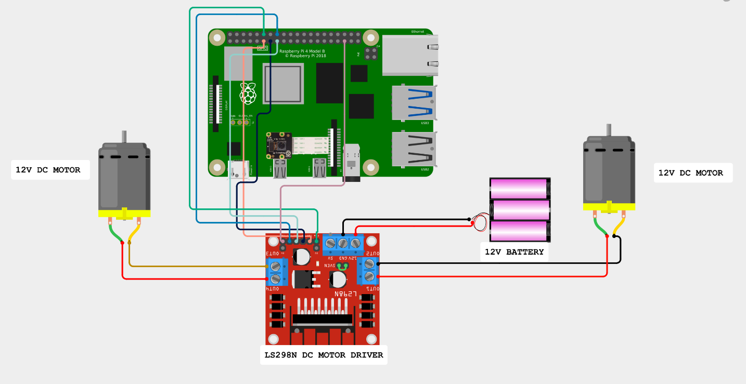
Fig. 2. Circuit Connections

Connection Table
From | To | Function
Raspberry Pi GPIO18  (Physical Pin No. 12) | L298N ENA | PWM Speed Control (Motor A)
Raspberry Pi GPIO19 (Pin 35) | L298N ENB | PWM Speed Control (Motor B)
Raspberry Pi GPIO17 (Pin 11) | L298N IN1 | Direction Control (Motor A)
Raspberry Pi GPIO27 (Pin 13) | L298N IN2 | Direction Control (Motor A)
Raspberry Pi GPIO22 (Pin 15) | L298N IN3 | Direction Control (Motor B)
Raspberry Pi GPIO23 (Pin 16) | L298N IN4 | Direction Control (Motor B)
L298N onboard regulator | L298N 5V | Logic Supply
Raspberry Pi GND (Pin 6) | L298N GND | Common Ground
Li-ion Battery (+) | L298N VS | Motor Power Supply
Li-ion Battery (–) | L298N GND | Power Ground

Important Notes

- The Raspberry Pi GPIO pins are configured as digital output pins to control the L298N motor driver.
- The GPIO18 (Physical Pin 12) is connected to ENA and GPIO19 (Physical Pin 35) is connected to ENB. Both pins are set to HIGH in the program to enable Motor A and Motor B.
- GPIO17 (Physical Pin 11) and GPIO27 (Physical Pin 13) are connected to IN1 and IN2 respectively and are used to control the direction of Motor A.
- GPIO22 (Physical Pin 15) and GPIO23 (Physical Pin 16) are connected to IN3 and IN4 respectively and are used to control the direction of Motor B.
- The Raspberry Pi GND must be connected to the L298N GND to establish a common ground between the two devices.
- The Li-ion battery is connected to the VS/12V and GND terminals of the L298N to provide power to the DC motors.
- The 5V-EN jumper is kept installed on the L298N. With the appropriate motor supply connected, the onboard regulator provides the required logic supply for the L298N.The Raspberry Pi 5V pin is not connected to the L298N 5V pin when the 5V-EN jumper is installed.
- The direction of Motor A is controlled by the logic levels applied to IN1 and IN2, while the direction of Motor B is controlled by IN3 and IN4.
- For forward motion, the program applies the same forward logic combination to both motors. For reverse motion, the logic levels are reversed for both motors.
- To stop the motors, IN1, IN2, IN3, and IN4 are set LOW.
- The motor power supply and Raspberry Pi power supply are kept separate, while their grounds are connected together.

Procedure
Procedure
- Connect the two DC motors to the OUT1–OUT2 and OUT3–OUT4 terminals of the L298N motor driver.
- Connect the Raspberry Pi 5 to the L298N according to the Connection Table:
- Connect the positive terminal of the Li-ion battery to the VS/12V terminal of the L298N and the negative terminal to GND.
- Ensure that the 5V-EN jumper is installed on the L298N.
- Power the Raspberry Pi 5 using its USB power supply.

- Note: If the Raspberry Pi is being booted for the first time, follow the setup procedure provided in Chapter 9 before proceeding with this experiment.

- Connect the Raspberry Pi and the Windows computer to the same network.

- Open Command Prompt (CMD) on the Windows computer.

- Establish a remote terminal connection to the Raspberry Pi using SSH by entering:
ssh <username>@<raspberry_pi_ip_address>
- Enter the Raspberry Pi password when prompted. After successful authentication, the Raspberry Pi terminal is accessed through Windows CMD.

- Verify that Python 3 is available on the Raspberry Pi by executing:
python3 –version

- Create a Python program file named motor_control.py using:
nano motor_control.py

- Enter the given Python program into the file and save it.
- Save the file using Ctrl + O, press Enter, and exit using Ctrl + X.

- Execute the program using:
python3 motor_control.py

- Observe the motor operation. The program performs the following sequence:
  - Both motors move forward for 5 seconds.
  - Both motors stop for 2 seconds.
  - Both motors move in reverse for 5 seconds.
  - Both motors stop for 2 seconds.
- The sequence continues to repeat until the program is interrupted.
- Press Ctrl + C in the terminal to stop the program. The program stops the motors and releases the GPIO resources using GPIO.cleanup().

Code

import RPi.GPIO as GPIO
from time import sleep

# --------------------------------------------------
# GPIO Pin Definitions
# --------------------------------------------------
# ENA and ENB are the enable pins of the L298N.
# IN1 and IN2 control the direction of Motor A.
# IN3 and IN4 control the direction of Motor B.

ENA = 18
IN1 = 17
IN2 = 27

ENB = 19
IN3 = 22
IN4 = 23

# --------------------------------------------------
# GPIO Setup
# --------------------------------------------------
# Use BCM numbering for Raspberry Pi GPIO pins.
GPIO.setmode(GPIO.BCM)

# Disable GPIO warning messages.
GPIO.setwarnings(False)

# Store all motor-control GPIO pins in a list.
motor_pins = [ENA, IN1, IN2, ENB, IN3, IN4]

# Configure all motor-control pins as outputs.
for pin in motor_pins:
GPIO.setup(pin, GPIO.OUT)

# --------------------------------------------------
# Enable Both Motors
# --------------------------------------------------
# Setting ENA and ENB HIGH enables Motor A and Motor B.
GPIO.output(ENA, GPIO.HIGH)
GPIO.output(ENB, GPIO.HIGH)

# --------------------------------------------------
# Motor Control Functions
# --------------------------------------------------

def forward():
# Motor A: IN1 HIGH and IN2 LOW
# causes Motor A to rotate in the forward direction.
GPIO.output(IN1, GPIO.HIGH)
GPIO.output(IN2, GPIO.LOW)

# Motor B: IN3 HIGH and IN4 LOW
# causes Motor B to rotate in the forward direction.
GPIO.output(IN3, GPIO.HIGH)
GPIO.output(IN4, GPIO.LOW)

print("Moving Forward")

def reverse():
# Reverse the logic levels of Motor A.
# This reverses the direction of Motor A.
GPIO.output(IN1, GPIO.LOW)
GPIO.output(IN2, GPIO.HIGH)

# Reverse the logic levels of Motor B.
# This reverses the direction of Motor B.
GPIO.output(IN3, GPIO.LOW)
GPIO.output(IN4, GPIO.HIGH)

print("Moving Reverse")

def stop():
# Set both direction inputs of Motor A LOW.
GPIO.output(IN1, GPIO.LOW)
GPIO.output(IN2, GPIO.LOW)

# Set both direction inputs of Motor B LOW.
GPIO.output(IN3, GPIO.LOW)
GPIO.output(IN4, GPIO.LOW)

print("Motors Stopped")

# --------------------------------------------------
# Main Program
# --------------------------------------------------
try:
# Continuously repeat the motor-control sequence.
while True:

# Move both motors forward for 5 seconds.
forward()
sleep(5)

# Stop both motors for 2 seconds.
stop()
sleep(2)

# Move both motors in reverse for 5 seconds.
reverse()
sleep(5)

# Stop both motors for 2 seconds.
stop()
sleep(2)

# --------------------------------------------------
# Program Termination
# --------------------------------------------------
except KeyboardInterrupt:
# This block executes when Ctrl + C is pressed.
print("\nProgram Terminated")

finally:
# Ensure the motors are stopped before exiting.
stop()

# Release the GPIO resources used by the program.
GPIO.cleanup()

Output

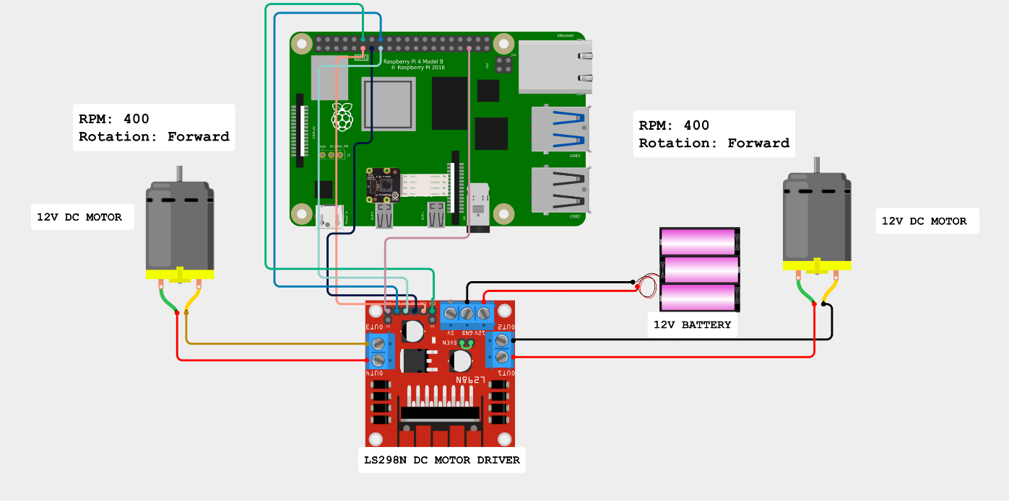

Fig. 3. Motor Rotation Output

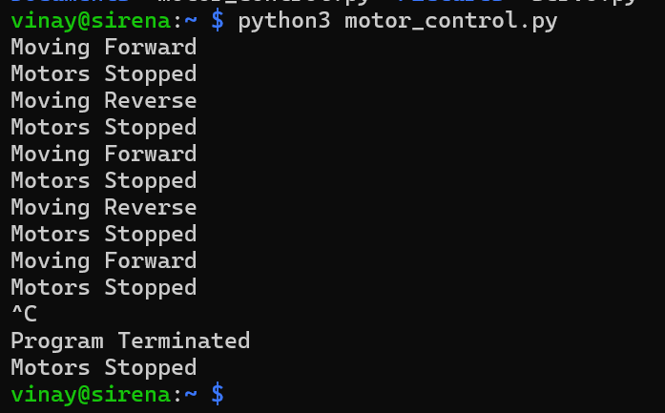

Fig. 4. Terminal Output

Observations
- The Raspberry Pi successfully established communication with the L298N motor driver through the configured GPIO pins.
- Both DC motors rotated in the forward direction when the forward control signals were applied.
- Both motors stopped when the direction-control inputs were set LOW.
- Both DC motors rotated in the reverse direction when the reverse control signals were applied.
- The motors followed the programmed sequence of forward → stop → reverse → stop.
- The corresponding motor status messages, such as “Moving Forward,” “Motors Stopped,” and “Moving Reverse,” were displayed in the Raspberry Pi terminal.
- The programmed time intervals of 5 seconds for movement and 2 seconds for stopping were observed during operation.
- The sequence continued to repeat until the program was terminated using Ctrl + C.

Result
The direction of two DC motors was successfully controlled using the Raspberry Pi 5 (4 GB) and L298N motor driver. The motors were operated in forward, stop, and reverse directions by applying appropriate digital control signals through the Raspberry Pi GPIO pins.

Speed and Position Control

Introduction
Robotic systems often require motors to operate at different speeds and positions depending on the task being performed. For example, a mobile robot may need to move slowly while avoiding obstacles and faster when travelling across an open area. Similarly, a robotic arm must position its joints accurately to pick up and place objects.
Two important motor control techniques used in embedded systems are speed control and position control.
- Speed control adjusts how fast a motor rotates.
- Position control moves a motor to a desired angle or position.
Arduino provides simple methods to perform both types of control using Pulse Width Modulation (PWM) and servo control libraries. These techniques are widely used in robotics, automation, and mechatronic systems.

Definition
Speed Control is the process of regulating the rotational speed of a motor to achieve the desired performance.
Position Control is the process of moving a motor or actuator to a specific angular or linear position.

Speed Control of a DC Motor
The speed of a DC motor depends on the amount of electrical power supplied to it.
Instead of continuously changing the supply voltage, Arduino controls motor speed using Pulse Width Modulation (PWM).
By varying the duty cycle of the PWM signal, the average voltage supplied to the motor changes, thereby controlling its speed.

Pulse Width Modulation (PWM)
Pulse Width Modulation is a technique in which a digital signal switches rapidly between HIGH and LOW states.
The ratio of the ON time to the total cycle time is called the duty cycle.

Effect of Duty Cycle on Motor Speed
Duty Cycle | Motor Speed
0% | Motor Stopped
25% | Low Speed
50% | Medium Speed
75% | High Speed
100% | Maximum Speed
Increasing the duty cycle increases the average power delivered to the motor, resulting in higher speed.

Arduino PWM Output
Arduino provides dedicated PWM output pins that generate PWM signals.
The analogWrite() function is commonly used to set the PWM value.
analogWrite(PWM_Pin, PWM_Value);
The PWM value ranges from:
- 0 – Motor OFF
- 255 – Maximum Speed
Intermediate values produce corresponding motor speeds.

Position Control of a Servo Motor
Unlike a DC motor, a servo motor rotates to a specified angular position.
The Arduino controls the servo by sending PWM-based control signals that correspond to the desired angle.
Typical positions include:
- 0°
- 45°
- 90°
- 135°
- 180°
Servo motors maintain the selected position until a new command is received.
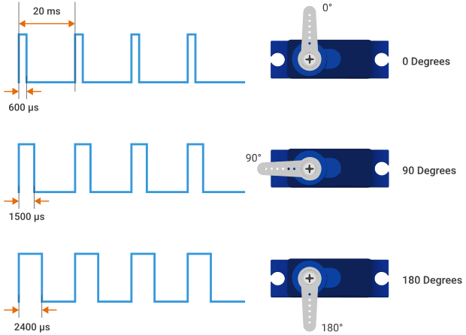
Figure 7.5: Servo Motor at Different Angular Positions

Comparison Between Speed Control and Position Control
Feature | Speed Control | Position Control
Purpose | Controls rotational speed | Controls angular position
Motor Used | DC Motor | Servo Motor
Control Method | PWM Duty Cycle | Servo Control Signal
Output | Continuous rotation | Fixed position
Common Applications | Robot movement | Robotic arm positioning

Applications

Speed Control
- Mobile robots
- Conveyor belts
- Cooling fans
- Electric vehicles
- Industrial automation

Position Control
- Robotic arms
- Camera pan-tilt systems
- Automatic gates
- Pick-and-place robots
- CNC machines

Activity: Servo Motor Direction Control using Raspberry Pi 5B

Aim
To interface a servo motor with the Raspberry Pi 5 (4 GB) and control its angular position using PWM signals, demonstrating clockwise and anticlockwise movement through a predefined sequence of angular positions.

Components Required
Component | Quantity
Raspberry Pi 5 Model B | 1
Breadboard | 1
Servo Motor | 1
Jumper Wires | As required
USB Cable | 1
MicroSD Card with Raspberry Pi OS | 1

Theory
- A servo motor is an actuator used to control the angular position of a shaft within a specified range.
- A servo motor typically has three connections: VCC, GND, and Signal.
- The VCC and GND connections provide power to the servo motor, while the Signal connection receives the control signal from the Raspberry Pi.
- The angular position of a servo motor is controlled using a Pulse Width Modulation (PWM) signal.
- In this experiment, the Raspberry Pi generates a PWM signal through GPIO17 to control the angular position of the servo motor.
- A typical servo motor operates using a PWM signal with a frequency of approximately 50 Hz, corresponding to a period of 20 ms.
- The pulse width of the PWM signal determines the position of the servo shaft. Different pulse widths correspond to different angular positions.
- By changing the PWM signal according to the required angle, the servo motor can be positioned at specific angles such as 0°, 45°, 90°, and 135°.
- In this experiment, the servo motor is programmed to move through a predefined sequence of angular positions, demonstrating both clockwise and anticlockwise

Schematic Diagram
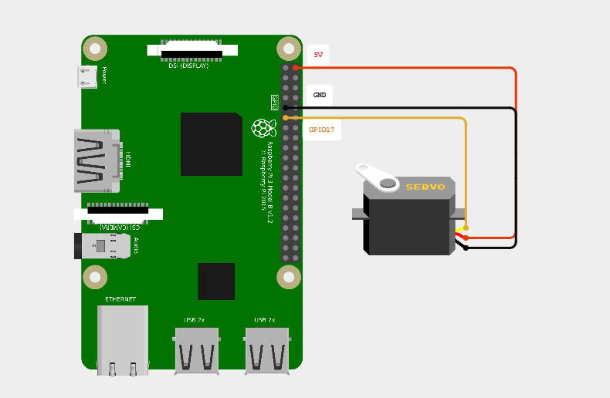

Fig. 2. Circuit Connections

Connection Table
From | To | Function
Raspberry Pi GPIO17 (Pin 11) | Servo Signal | Direction Control
Raspberry Pi GND (Pin 6) | Servo GND | Common Ground
Raspberry Vcc (Pin 2) | Servo VS | Servo Motor Power Supply

Procedure

- Connect the servo motor to the Raspberry Pi 5 according to the Connection Table.
- Connect the servo Signal wire to GPIO17 (Physical Pin 11).
- Connect the servo VCC wire to the 5V pin of the Raspberry Pi.
- Connect the servo GND wire to a GND pin of the Raspberry Pi.
- If the Raspberry Pi is being booted for the first time, follow the setup procedure mentioned in Chapter 9 before proceeding with this experiment.
- Connect the Raspberry Pi and Windows computer to the same network.
- Open Command Prompt (CMD) on the Windows computer.

- Access the Raspberry Pi using SSH:
ssh <username>@<raspberry_pi_ip_address>

- Enter the Raspberry Pi password when prompted.

- Create the Python program file:
nano servo_control.py

- Enter the given Python code into the file.
- Save the file using Ctrl + O, press Enter, and exit using Ctrl + X.

- Run the program using:
python3 servo_control.py

- Observe the servo motor moving through the programmed sequence:
- 0° → 90° → 45° → 135° → 0°
- Observe the clockwise and anticlockwise movement of the servo motor between the specified angular positions.
- Press Ctrl + C to terminate the program.

Code

import RPi.GPIO as GPIO
from time import sleep

# --------------------------------------------------
# GPIO Pin Definition
# --------------------------------------------------
# Servo signal is connected to GPIO17.

SERVO_PIN = 17

# --------------------------------------------------
# GPIO Setup
# --------------------------------------------------
# Use BCM numbering for Raspberry Pi GPIO pins.
GPIO.setmode(GPIO.BCM)
GPIO.setwarnings(False)

# Configure GPIO17 as an output pin.
GPIO.setup(SERVO_PIN, GPIO.OUT)

# --------------------------------------------------
# Servo PWM Setup
# --------------------------------------------------
# A typical servo motor operates at 50 Hz PWM.
servo = GPIO.PWM(SERVO_PIN, 50)

# Start PWM with 0% duty cycle.
servo.start(0)

# --------------------------------------------------
# Servo Angle Control Function
# --------------------------------------------------
def set_angle(angle):

# Convert the required angle into a PWM duty cycle.
duty = 2 + (angle / 18)

# Apply the calculated duty cycle to the servo.
servo.ChangeDutyCycle(duty)

# Allow the servo time to reach the required position.
sleep(1)

# Stop the pulse after reaching the position.
servo.ChangeDutyCycle(0)

# --------------------------------------------------
# Main Program
# --------------------------------------------------
try:
while True:

# Move to 0° - Initial Position
print("Servo Angle: 0°")
set_angle(0)
sleep(1)

# Move to 90° - Clockwise
print("Servo Angle: 90°")
set_angle(90)
sleep(1)

# Move to 45° - Anticlockwise
print("Servo Angle: 45°")
set_angle(45)
sleep(1)

# Move to 135° - Clockwise
print("Servo Angle: 135°")
set_angle(135)
sleep(1)

# Return to 0° - Anticlockwise
print("Servo Angle: 0°")
set_angle(0)
sleep(1)

# --------------------------------------------------
# Program Termination
# --------------------------------------------------
except KeyboardInterrupt:
print("\nProgram Terminated")

finally:
# Stop PWM and release the GPIO pin.
servo.stop()
GPIO.cleanup()

Output

Fig. 3. Motor Rotation Output

Fig. 4. Terminal Output

Observations
- The Raspberry Pi successfully generated the PWM control signal through GPIO17.
- The servo motor responded to the PWM signal and moved to the programmed angular positions.
- The servo motor initially moved to 0° and then followed the programmed sequence.
- The servo motor moved from 0° to 90° in the clockwise direction.
- The servo motor moved from 90° to 45° in the anticlockwise direction.
- The servo motor moved from 45° to 135° in the clockwise direction.
- The servo motor returned from 135° to 0° in the anticlockwise direction.
- The corresponding servo angle was displayed in the Raspberry Pi terminal during each movement.
- The programmed sequence 0° → 90° → 45° → 135° → 0° was repeated continuously until the program was terminated.

Result
The angular position of the servo motor was successfully controlled using the Raspberry Pi 5 (4 GB) by generating PWM signals through GPIO17. The servo motor successfully followed the programmed sequence of 0° → 90° → 45° → 135° → 0°, demonstrating controlled clockwise and anticlockwise angular movement.

Importance in Robotics
Efficient robotic systems require both speed and position control.
Examples include:
- A mobile robot adjusts wheel speed for smooth navigation.
- A robotic arm accurately positions its joints for object handling.
- An autonomous robot slows down near obstacles and increases speed in open areas.
- A camera mounted on a robot is positioned accurately using a servo motor.
By combining both techniques, robots achieve smooth movement and precise operation.

